Scatter Plot Directions:
Click the double Square box at the top right (next to the red x) so you can view this and the Graph Maker at the same time.
Go to the link for Graph Maker and then click Scatter Plot. (And click the double Square here as well to see these directions, too.)
Enter the data you collected and your graph titles.
The NUMBER of VALUE SET = the number of data entries you have with an x and y value (Say you measured the height and weight of 12 people, then here you would enter 12.)
HOWEVER if you want to show two separate sets on one graph like Males and Females, enter the most of either. (Say you measured the height and weight of 5 males and 6 females, enter 6 here AND then enter 2 for NUMBER of ITEM …males and females = 2.)
(If you just have one set of subjects or information that is not grouped then leave NUMBER of ITEM as 1.)
At the bottom of this page it allows you to choose a color for each. I chose blue for Males and for pink I clicked the chose color button under the selections and was able to choose a pink value.

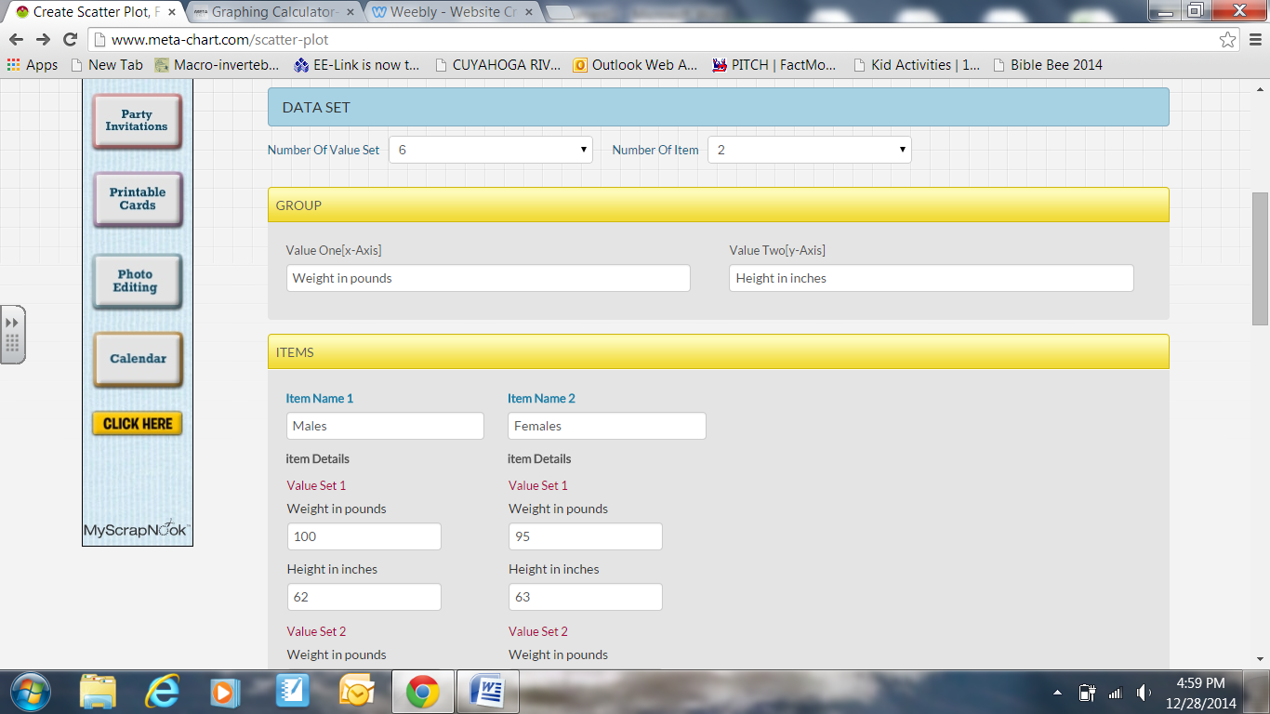

Add a Title and for this YOU ARE the source. This is YOUR data. So, give yourself credit. Go simple to start and if you want to change color or font, come back to this page with the back arrow at the top.
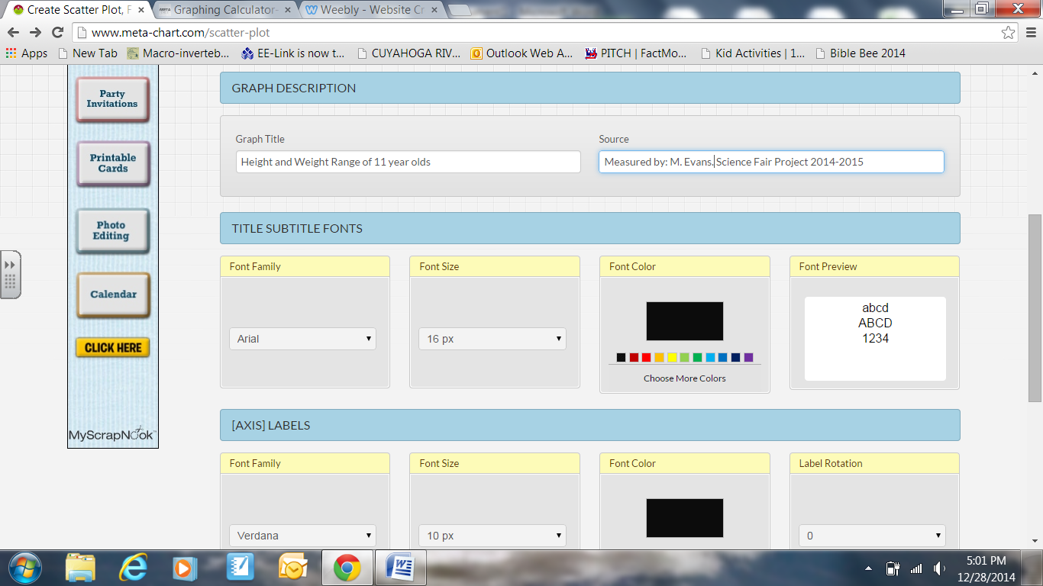

This Scatter Plot shows some correlation between height and weight because even though there is NOT a clear line, there is no information in the upper left corner or lower right corner showing the that basically the more someone weighs, that in general, the taller they are. (See below.)
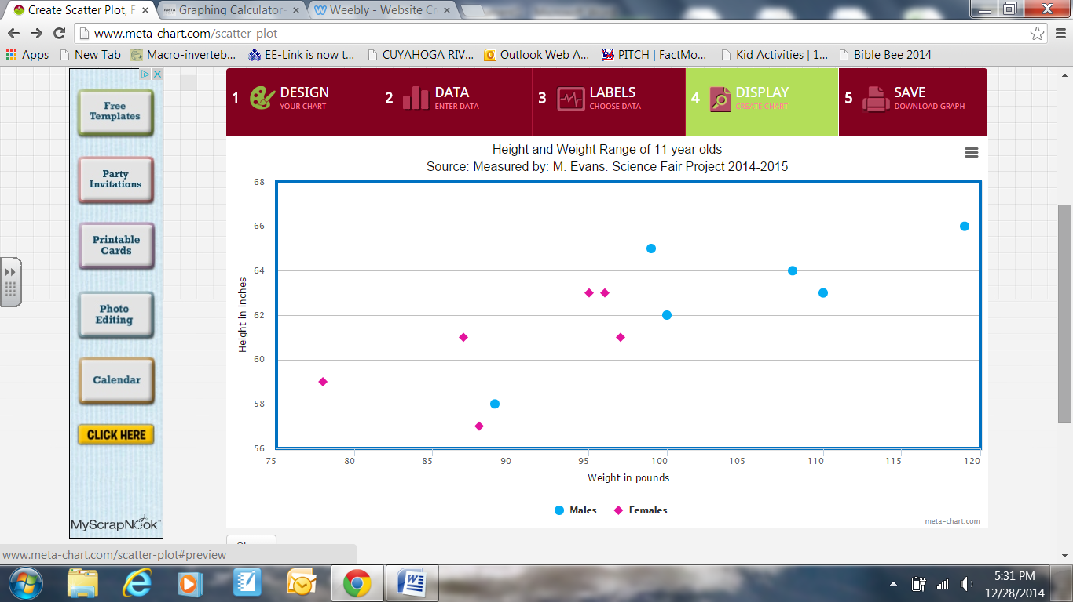

Now, I added more data that throws off the correlation. This plot shows NO CORRELATION as there data points are “all over the place”. If yours looks like this, you may want to try a different graph OR it might be that your project truly does not show a correlation or your hypothesis may be false. Let me know if you need help interpreting what your graph shows or what your data means.
